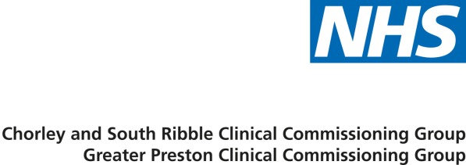

Communications Toolkit:

Reopening of emergency department at Chorley and South Ribble District General Hospital

This document provides information and materials to support the reopening of the emergency department at Chorley and South Ribble District General Hospital. The campaign aims to provide clear, consistent and accurate messaging to build awareness of service provision at the emergency department and to build confidence in the local Urgent and Emergency care pathways in central Lancashire.
The following information is contained below:
- Key messages
- Website content
- Infographic
- Suggested social media posts
- Suggested artwork
We will continue to update and share this toolkit with the latest resources.
If you have any questions or queries about the content of this toolkit, please contact charlotte.hargreaves@nhs.net.

Key messages
Overarching core messages
- The emergency department at Chorley and South Ribble District General Hospital (DGH) will reopen on Monday 2 November.
- The department will accept patients from 8am until 5pm each day. Senior decision making clinicians (consultants and middle-grade doctors) will be on hand until 7pm to assess and manage care for patients arriving close to 5pm.
- The A&E service at CDH will initially be an adult’s only service.

- Any child or young person (under 18 years of age) needing A&E services should attend the Royal Preston A&E to ensure that they get the best care in the right place. If these patients visit Chorley A&E, they will be safely transferred to the Royal Preston.

- Royal Preston Hospital is the best place for the appropriate care of any pregnant women, children and young people in an emergency situation.

- The reopening has only been possible because of many months of hard work by colleagues across the Trust, particularly the Emergency Department team who have all gone above and beyond during this pandemic.

Specific messages to support the services available at CDH
- The A&E service at CDH will initially be an adult’s only service.

- Adult ambulance patients will be taken to Chorley between 8am and 5pm if appropriate. Outside of these hours, ambulance patients will be taken to Royal Preston Hospital.

- If your child is seriously unwell and requires A&E, please go straight to Royal Preston Hospital.

- If you are pregnant or think you may be pregnant and require A&E, please go straight to Royal Preston Hospital.

- As a major trauma centre, with clinicians who are highly trained and experienced in treating complex broken bones and/or life-threatening injuries, the Royal Preston Hospital is the most appropriate place for this type of care.

- If you or a loved one suffer a serious fracture or broken bone then please go straight to Royal Preston Hospital.

- Adults and children will continue to have access to the 24/7 Urgent Care Centre at Chorley. The Urgent Care Centre can treat a wide range of minor ailments.

- Most patients with minor injury or illness can be treated by an urgent care service.

- The UCC will provide a prompt and timely treatment of minor injury and illness 24 hours a day, such as (but not limited to):
- Minor nose bleeds
- Cuts, bites and stings
- Burns and scalds
- Infections (including abscesses)
- Foreign bodies in wounds, ears and noses
- Muscular sprains and strains to shoulders, arms and legs
- Fractures to shoulders, arms, legs & ribs
- Dislocations of fingers, thumbs and toes
- Minor eye conditions including conjunctivitis and foreign bodies
- Minor chest, neck and back injuries
- Minor head injuries with no loss of consciousness or alcohol-related
- Minor allergic reactions
- Minor ailments such as earache, urinary tract infections and sinusitis
- Diarrhoea / Constipation
- Emergency contraception
- Some patients will require the services provided at Royal Preston Hospital and pathways remain in place to care for them. These include:
- Extensive trauma
- Extensive burns
- Patients requiring resuscitation
- Suspected acute heart attack
- Suspected acute stroke
- High risk gastrointestinal haemorrhage
- All children and young people
- Pregnant women
- Anybody suffering a complex fracture or broken bone.

Website content
The Emergency Department at Chorley and South Ribble District Hospital
About the service:
The emergency department at Chorley and South Ribble District Hospital will reopen on Monday 02 November 2020.
The A&E service at Chorley and South Ribble District Hospital will initially open as an adult’s only service.
Children or young people under the age of 18, and pregnant women needing A&E services in an emergency situation should go to the Royal Preston Hospital to ensure they get the most appropriate care.
Most patients with minor injury or illness can be treated by an Urgent Care Service.

Opening hours:
The department will accept patients from 8am until 5pm each day.
Between 8am – 5pm ambulances will transport patients to Chorley if appropriate.
Outside of these hours, ambulance patients will be taken to Royal Preston Hospital.
You should not attend the A&E service at Chorley and South Ribble Hospital in the following circumstances:
• You are pregnant
• You are under the age of 18
• You suffer a badly broken bone
• You suspect a heart attack or stroke
• You suspect internal bleeding
• You suffer extensive burns
• You suffer extensive trauma

In any of these circumstances, please go directly to Royal Preston A&E department. Patients requiring resuscitation or suffering from high risk internal bleeding will also be taken straight to the Royal Preston Hospital.

Coronavirus symptoms:
If you have a high temperature or a new continuous cough or a loss or change to your normal sense of taste or smell, please use the NHS 111 online coronavirus service: https://111.nhs.uk/covid-19
You should only call NHS 111 if you cannot get help online.

Urgent medical help:
For urgent medical help, not related to coronavirus, please use the NHS 111 online service: https://111.nhs.uk/
You should only call NHS 111 if you cannot get help online.

Emergencies:
In an emergency, call 999

Urgent Care Centre:
The 24/7 Urgent Care Centre at Chorley and South Ribble District General Hospital can treat a wide range of minor ailments, for both children and adults, including:
• Minor nose bleeds
• Cuts, bites and stings
• Burns and scalds
• Infections (including abscesses)
• Foreign bodies in wounds, ears and noses
• Muscular sprains and strains to shoulders, arms and legs
• Fractures to shoulders, arms, legs & ribs
• Dislocations of fingers, thumbs and toes
• Minor eye conditions including conjunctivitis and foreign bodies
• Minor chest, neck and back injuries
• Minor head injuries with no loss of consciousness or alcohol-related
• Minor allergic reactions
• Minor ailments such as earache, urinary tract infections and sinusitis
• Diarrhoea / Constipation
• Emergency contraception

For more information on services, please visit:
www.lancsteachinghospitals.nhs.uk

Social media posts
Please share these posts from 28 October 2020 on your social media channels.
Please ensure you are also following the CCG and Lancashire Teaching Hospitals NHS Foundation Trust social media accounts to retweet and share additional messages where possible:
Facebook: @NHSCSR | @GtrPrestonCCG | @LancsHospitals
Twitter: @NHSCSR | @GtrPrestonCCG | @LancsHospitals
Body text | Asset
The emergency department at Chorley and South Ribble District General Hospital will reopen on Monday 2 November 📆  The department will accept patients from 8am until 5pm each day 🕔  Learn more at: https://bit.ly/31twUzG and by following @LancsHospitals | 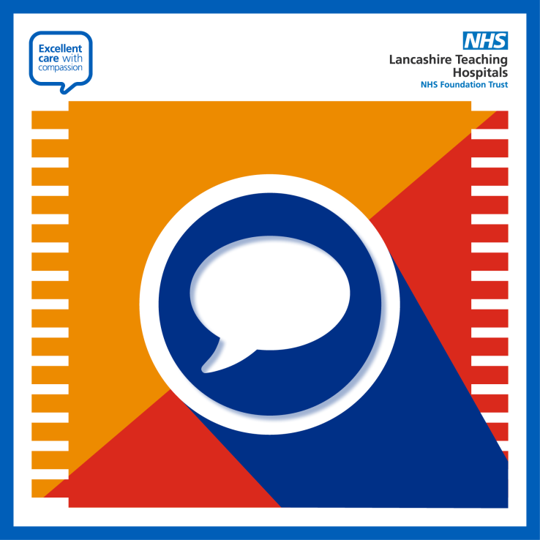
The A&E service at Chorley and South Ribble District General Hospital will initially open as an adults only service 👨👩✅  Between 8am and 5pm, ambulances will transport patients to Chorley if appropriate 🚑  Outside of these hours, ambulance patients will be taken to Royal Preston Hospital ✅  Find out more about the urgent care services available to you at: https://bit.ly/31twUzG  @LancsHospitals | 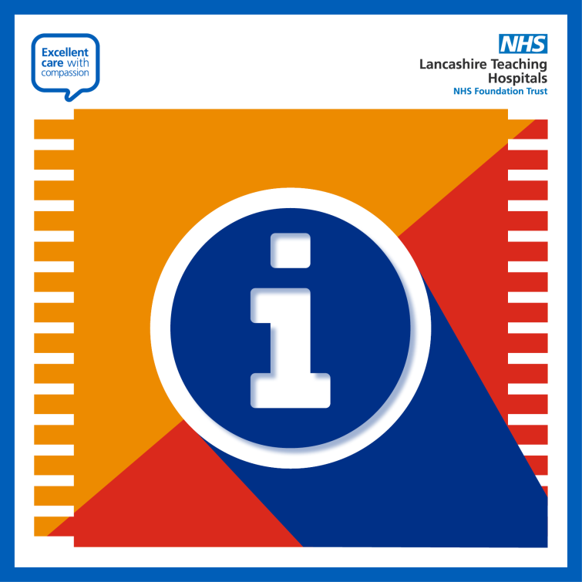
The A&E service at Chorley and South Ribble District General Hospital will reopen initially as an adults only service ☑️  Children or young people under the age of 18, and pregnant women needing A&E services in an emergency situation, will be taken to Royal Preston Hospital to ensure they get the most appropriate care 🧒🤰  You can read more about this here: https://bit.ly/31twUzG  @LancsHospitals | 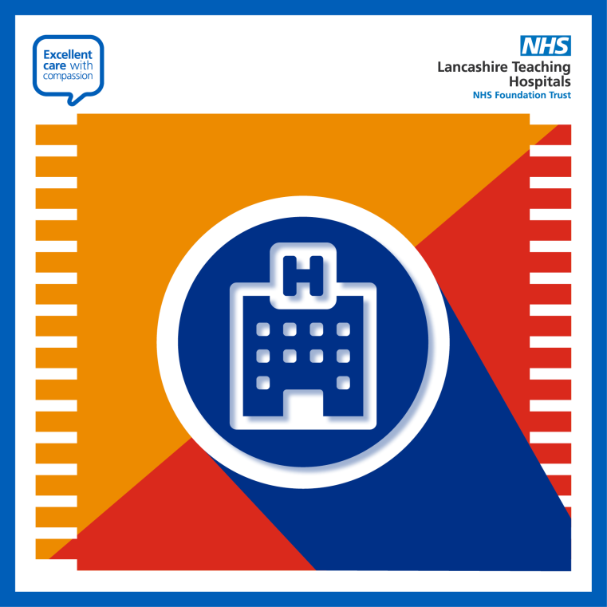
Royal Preston Hospital is the best place for the appropriate care of any pregnant women, children and young people in an emergency situation 🏥  If your child is seriously unwell and requires A&E, please go straight to Royal Preston Hospital☑️  Further information at: https://bit.ly/31twUzG  @LancsHospitals | 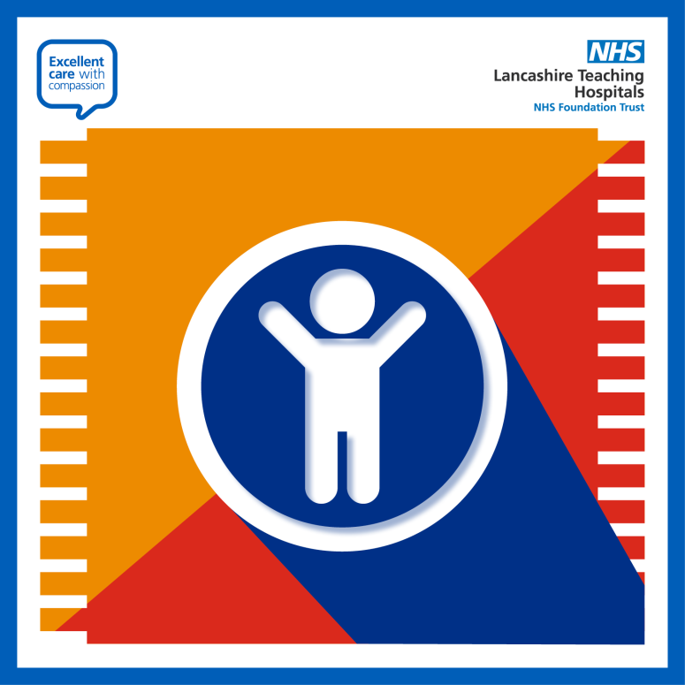
Royal Preston Hospital is the best place for the appropriate care of any pregnant women, children and young people in an emergency situation 🏥  If you are pregnant or think you may be pregnant and require A&E, please go straight to Royal Preston Hospital ☑️  Access further information at: https://bit.ly/31twUzG and by following @LancsHospitals | 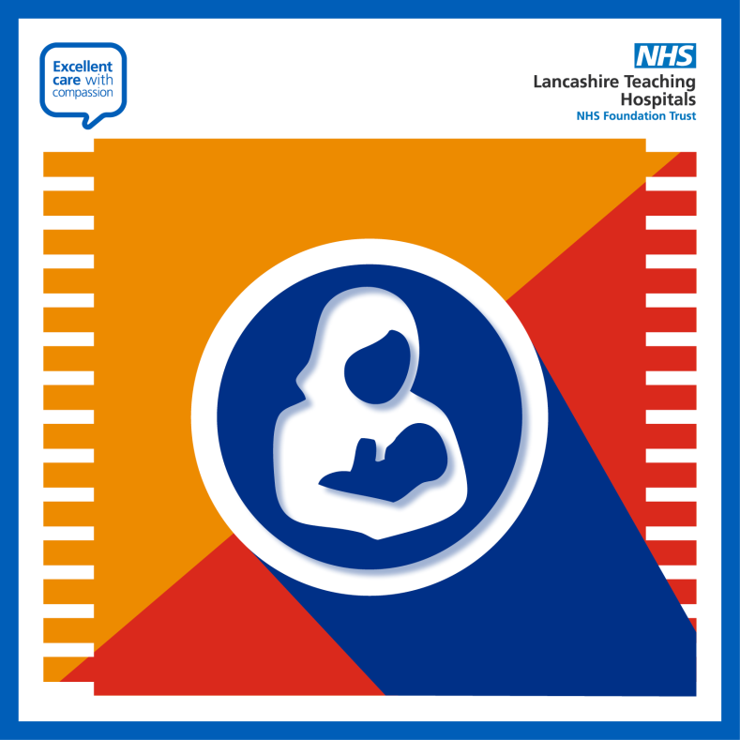
As a major trauma centre, with clinicians who are highly trained and experienced in treating complex broken bones and/or life-threatening injuries, the Royal Preston Hospital is the most appropriate place for this type of care 🏥  If you or a loved one suffer a serious fracture or broken bone then please go straight to Royal Preston Hospital.  Learn more by visiting: https://bit.ly/31twUzG and by following @LancsHospitals | 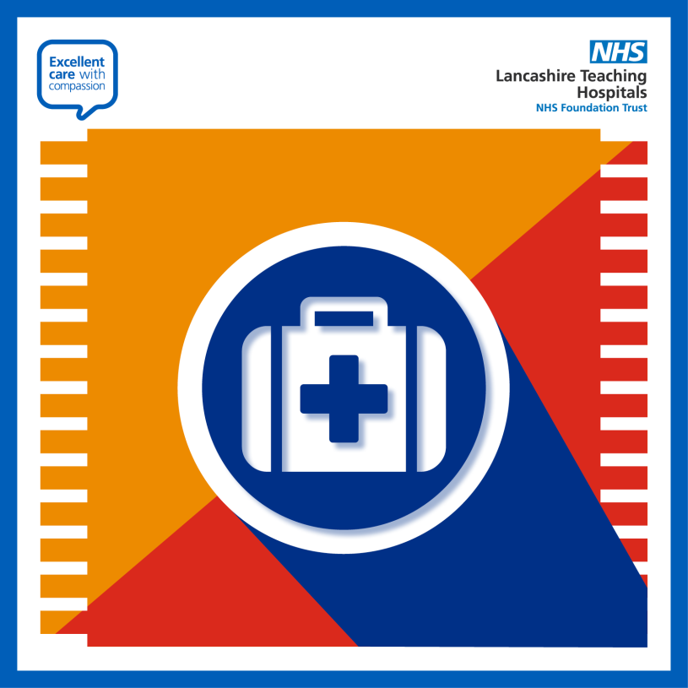
Most patients with minor injury or illness can be treated by an urgent care service ☑️  The 24/7 Urgent Care Centre at Chorley and South Ribble District General Hospital can treat a wide range of minor ailments, for both children and adults, including:  ▶️ Cuts, bites and stings  ▶️ Burns and scalds  ▶️ Minor eye conditions  ▶️ Minor allergic reactions  ▶️ Muscular sprains and strains to shoulders, arms and legs  and more.  Find the full list, opening times, directions and more at: https://bit.ly/31twUzG  @LancsHospitals | 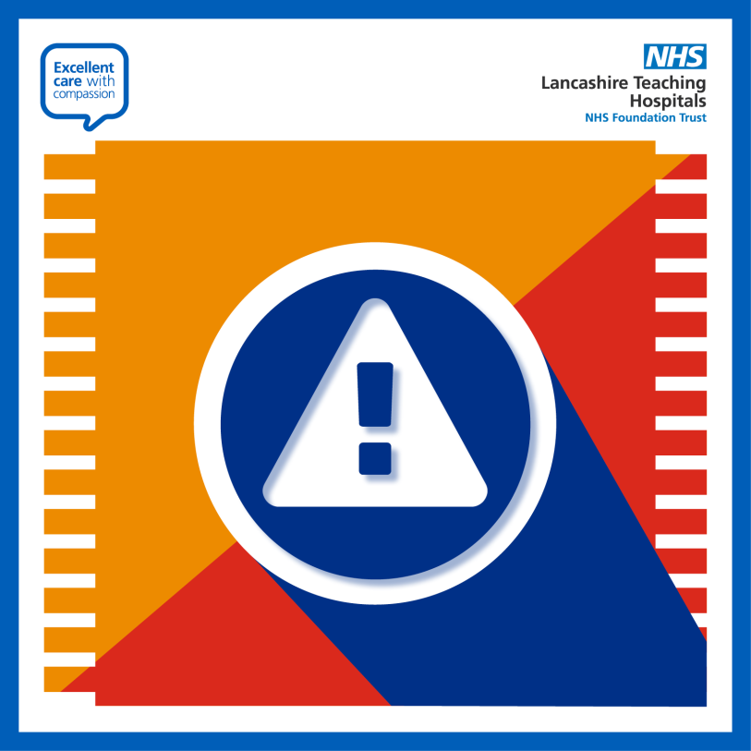
Dependant on your emergency care need, you may be taken to either Chorley and South Ribble District General Hospital or Royal Preston Hospital 🏥  This is to ensure you receive the most appropriate care for your condition because both hospitals have different specialties ☑️  You can learn more about this here: https://bit.ly/31twUzG and by following @LancsHospitals | 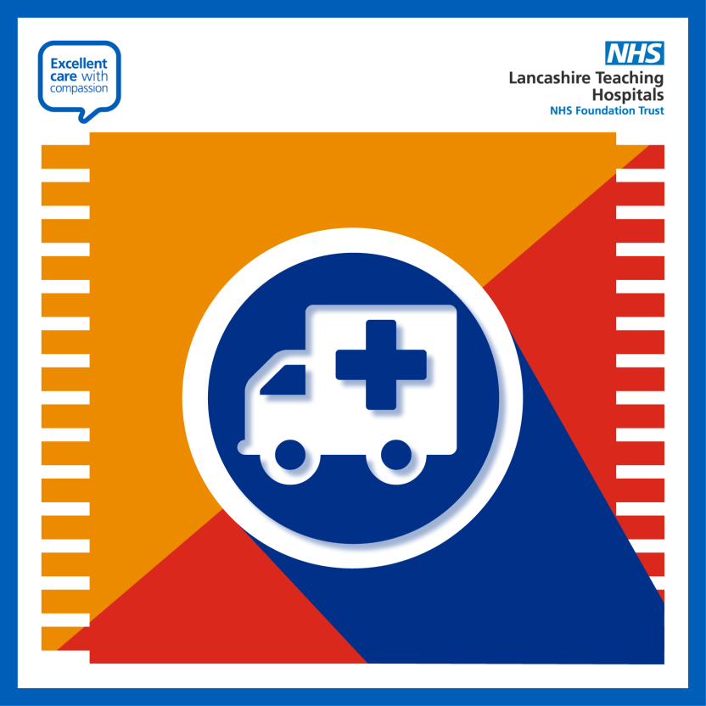
With the reopening of the emergency department at Chorley and South Ribble District General Hospital, @LancsHospitals have produced this helpful infographic: ℹ️  Simply download, save or screenshot this image to your camera roll to act as a handy guide on the urgent and emergency care services available to you 🏥✅  This and more at: https://bit.ly/31twUzG  @LancsHospitals | 